**Mortgage Calculator Project**

The purpose of this project is to build a mortgage calculator using the basics that I have learnt thus far.

This calculator will be able to calculate the mortgage payments based on the input that the user enters. The user will be asked a few questions that they will have to answer namely:

* The principal or amount of loan they want to get
* The annual Interest Rate
* The period in years

This program will be able to calculate the monthly payment and display it as a currency  
  
The formula for calculating mortgage payments is as follows:

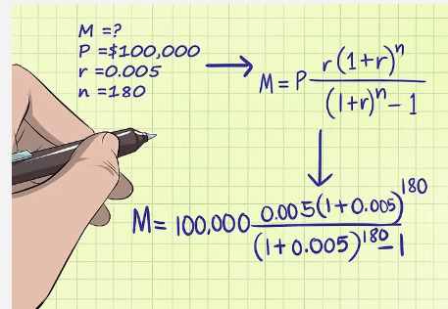  
P = Principal

r = monthly interest rate

n = number of payments